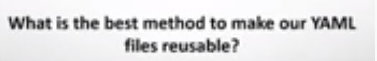





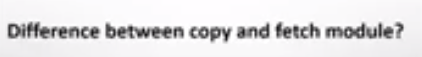

**What is Ansible Gathering facts?**

Gathering facts are the attributes of the machine.

**What is Variables and Loops?**

It helps you to use and assign a value to a variable and use that anywhere in the playbook. One can put conditions around the value of the variables and accordingly use them in the playbook.

**File module?**

changing ownership on several files and/or directories with the file module

**User module?**

creating multiple users with the user module

**List Variable?**

Used for install multiple packages at the same time.